

**A Mini -Project Report**

**On**

**“MOVIE TICKET BOOKING”**

**USING**

**Python**

**Submitted by:**

1. K.ADARSH (19B21A04B5)

2.M.AMARANADH (19B21A0496)

3.M.MAHALAKSHMI(19JN1A0505)

4. M.JYOTHI(19B21A0468)

5.CH NAGASWARUP(19B21A04C1)

**Departments**

Electronics and Communication Engineering and Computer Science Engineering.

**Submitted to**

**Dr.Krish Naik**

Chief Innovation Officer

**Submission Date: December 19,2021**

**INDEX**

ABSTRACT

SCOPE

INTRODUCTION

AIM

OBJECTIVE

TECHNOLOGIES USED

MODULES

SYSTEM REQUIREMENTS

CODE

STEPS INVOLVED

ADVANTAGES

CONCLUSION

**ABSTRACT:**

The purpose of online movie ticket booking system is to automate the existing mutual system by the help of computerized equipments and full-fledged computer software, full-fiedged computer software,fulfilling their requirements,so that their valuable data/information can be stored for a longer period with easy accesing and manipulation of the same.The required software and hardware are easily available and easy to work with for the clients.

Online Movie Ticket Booking System, as described above,can lead to error free,secure,reliable and fast management system.It can assist the user to concentrate on their other activities rather to concentrate on the record keeping.Thus it will help organization in better utilization of resources.The organization can maintain computerized records without redundant entries. That means that one need not be distracted by information that is not relevant, while being able to reach the information.Basically,the project describes how to maanger for good performance and better services.

**SCOPE:**

It may help collecting perfect management in details. In a very short time , the collection will be obvious, simple and sensible. It will help a person to know the management of passed year perfectly and vividly.It also helps in current all works relative to Online Movie Ticket Booking System**.**

Our project aims at Business process automation,i.e, we have tried to computerize various processes of Online Movie Ticket Booking System.

* In computer system the person hit as to fill the various forms&number of copies of the forms can be easily generated at a time.
* **.** In computer system,it is not necessary to create the manifies but we can directly print it,which saves our time.
* To assist the staff in capturing the effort spent on their respectiveworking areas.
* To utilize resources in an efficient manner by increasing their productivity through automation.
* The system generates types of information that can be used for various purposes.
* It satisfy the user requirement.
* Be easy to understand by the user and operator.
* Be easy to operate.
* Have a good user interface.
* Be expendable.
* Delivered on schedule within the budget.

**INTRODUCTION:**

The **Online Movie Ticket Booking System has been developed to override the problems prevealing in the practicing manual system,This softeware is supported tob eliminate and in some cases reduce the hardships faced by this existing system.Moreover this system is designed for the particular need of the company to carry out operations in a smooth and effective manner.**

**The application is reduced as much as possible to avoid errors while entering the data.It also provides error message while entering invalid data.No format knowledge is needed for the user to use this system.**

**AIM:**

The main aim of our project is that let the people can book their movie tickets through our project Online Movie Ticket Booking System.

**OBJECTIVE:**

The main ,objective of the project on Online Movie Ticket Booking System is to manage the details of Movie,Tickets,Booking Customer ,Seats,Show timimg.It manages all the information about Movie,Cinema Halls,Show timing,Movie.The project is totally built at administrative end and thus only nthe administrator is guaranteed the access.The purpose of the project is to build an application program to reduce the manual work for managing the Movie,Tickets,Cinema Halls,Booking Customer.It tracks all the details about the Booking Customer ,Seats,Show timing.

**Functionalities provided by Online Movie Ticket Booking System are as follows:**

* Provide the ,searching facilities based on various factors,Such as Movie,Booking Custome,Seats,Show timing.
* Online Movie Ticket Booking System alos manage the Cinema Halls details online for Seats details,Show timimg details,Movie.
* It tracks all the information of Ticket,Cinema Halls,Seats etc.
* Manage the information of Tickets.
* Shows the information and description of the Movie,Booking Customer.
* To increase efficiency of managing the Movie,Tickets.
* It deals with monitoring the information and transaction of Seats.
* Manage the information of Movie.
* Editing,adding and updating of Records is improved which results in proper resources management of Movie data.
* Manage the information of Seats.
* Integration of all records of Show timing.

**TECHNOLOGIES USED:**

* Python-Tkinter

**Report on Online Movie Booking System:**

* It generates the report on Movie,Tickets,Cinema Halls.
* Provide filter reports on Booking Customer,Seats,Show timing.
* You can easily export PDF for the Movie,Cinema Halls,Seats.
* Application also provides excel export for Tickets,Booking Customer,Show timing.
* You can also export the report into csv format for Movie,Tickets,Show timing.

MODULES:

* Movie Management Module:Used for managing the Movie details.
* Show timing Module:Used for managing the details of Show timing
* Cinema Halls Module:Used for managing the details of Cinema Halls.
* Ticket Management Module:Used for managing the information and details of the Tickets.
* Booking Customer Module:Used for managing the Booking Customer details.
* Seats Module:Used for managing the Seats informations
* Login Module:Used for managing the login details.
* Users Module:Used for manging the uesrs of the system.

**SYSTEM REQUIREMENTS:**

Hardware Requirements:

* RAM: 4GB and higher
* Processor: Intel i3 and above
* Hard Disk: 1tb minimum.

Software Requirements:

* Os:Windows
* Pycharm
* Language:Python

**CODE:**

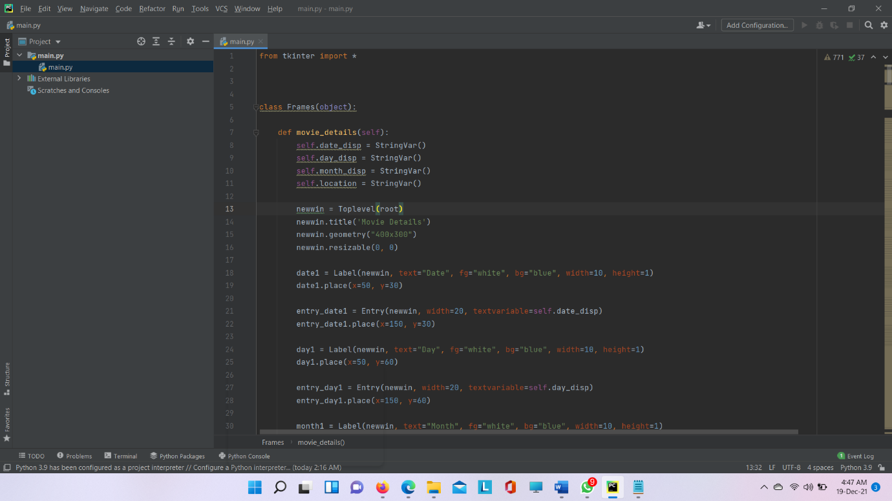

**STEPS INVOLVED**:

1.First,we need to copy the path of main code.

2.Then we have to open anaconda prompt.

3.we have to paste the path in prompt.

4.we have to give the file name(main.py) and press enter.

5.Then we will get the page ,in that we have a block like”processed to booking”.

6.if we click the block it will open the another page and it will ask the some enter details .

7.then it will open another page ,in that we have to enter details of the day and city which day and place we want to see the movie.

8.we will get another Page like in that we have list of theaters in that location according to the user requirement.so user have to select the theatre.

9.after we have to select movie name and select the slot then we will get seat numbers.according to user requirement ,he have to select the seat numbers and click on confirmation.

10.then ,we will get money pay page ,we have to pay the money through debit card and submitted.

11.after transaction successful,the seat will booked.

**ADVANTAGES:**

1.User time will be reduced like user can book their movie ticket through online.

2.it will take less time for booking as compared to many projects.

**OUTPUT SCREENS:**

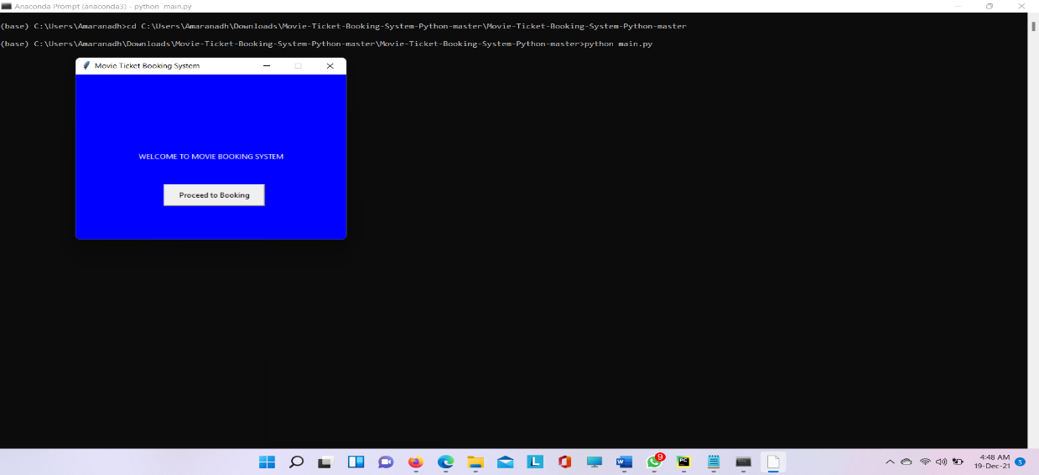

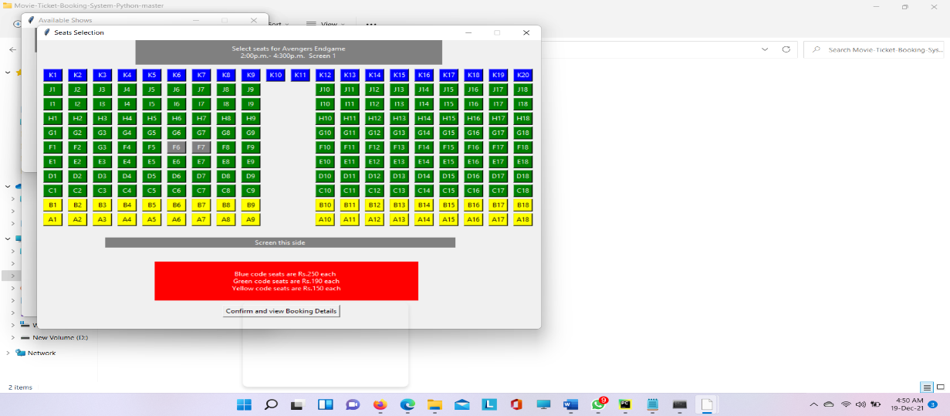

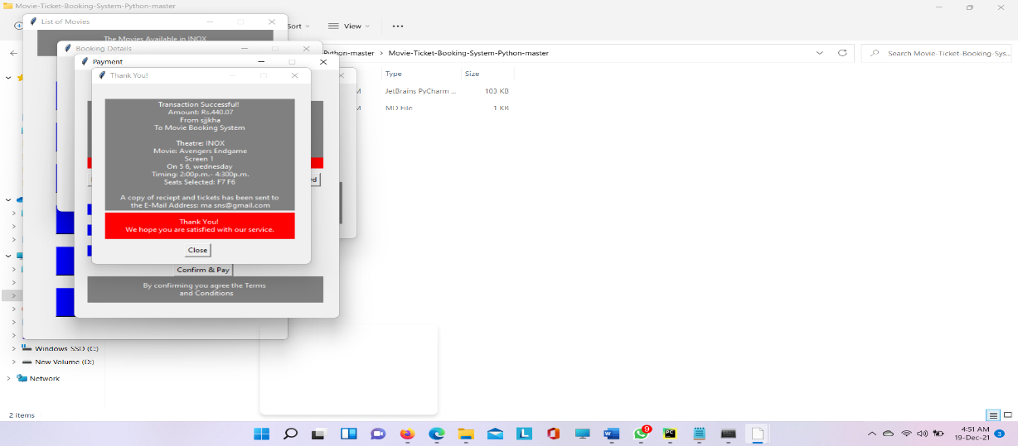

**CONCLUSION:**

Through this application program we can reduce the manual work of cinema hall workers for managing the Movie Tickets,Cinema Halls,Booking Customer.Also,user can save the time by booking the ticket in online without time wasting.

**THANK YOU**